OO Programming Fundamentals

Practical Class 2 – Week 30th September 2013

- Create a new folder in your java folder on your G drive and call it practical02
- Save all the following exercises into the practical02 folder
- Ensure that you move to the correct folder when using the Command Prompt Window:
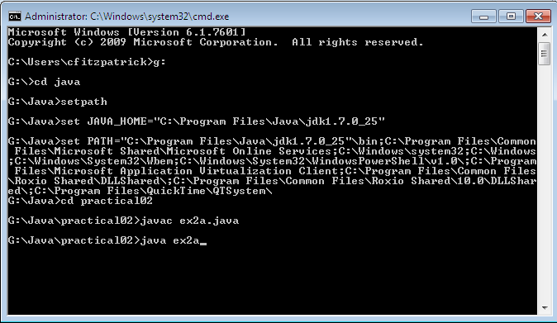
- You must run setpath from whichever folder it is stored in.

Exercise 1
Write a program that will evaluate the following: 2.2 + 3 / 3.1 and print the answer.
Save as ex2a.java
Sample Output:

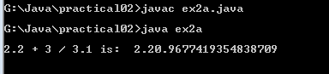

Exercise 2
Write the Greetings program from page 18 of the book – Asking the user to enter their name and printing a greeting to the screen.
Save as ex2b.java
Sample Output
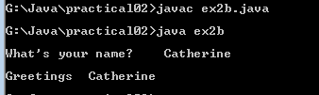

Exercise 3
Write a program to read any integer value from the user (keyboard), store it in a variable, calculate and output its square to the screen.
Save as ex2c.java
Sample Output:
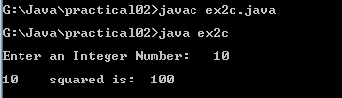

Exercise 4
Write a program that asks the user to enter the length and width of any rectangle and calculate and display its area.
Save as ex2d.java
Sample Output
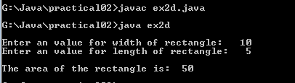

Exercise 5
Write a program to read any two decimal values from the user (keyboard), store the two values in two variables, calculate and output their average to the screen.
Save as ex2e.java

Sample Output:
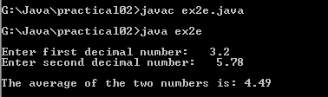
Exercise 6
Write a program that calculates an employee’s gross pay. Input to the program from the user (keyboard) is the hourly rate (i.e. how much they get paid per hour) and the number of hours worked per week. Calculate the gross pay and print the answer to the screen.
Save as ex2f.java
Sample Output:
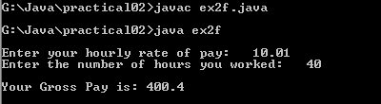

Exercise 7
Write a program to read values for the length, width and height of a rectangular box from the user (keyboard). The programs should calculate and print its volume to the screen.
Save as ex2g.java
Sample Output:
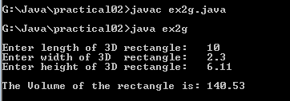

Completing this weeks’ Practical:
- When you submit work, you will send it in zip file format.
- To create a zip file of your practical work:
  - In Windows Explorer, right click on the practical02 folder that contains your work.
  - When the context menu appears, choose the Send to option, followed by the Compressed (zipped) folder.

  - This will create a new file called practical02.zip in your current folder, as highlighted in the image below.
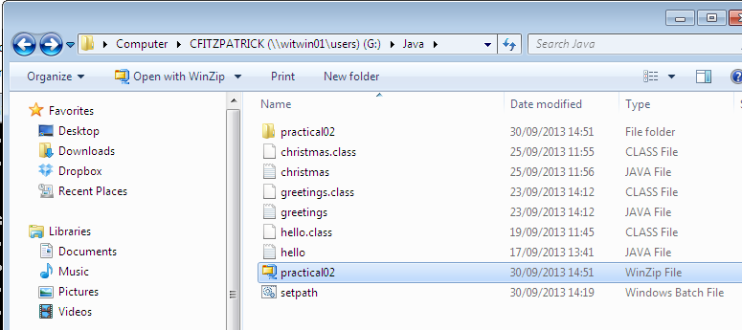

- Note: If you are using your own laptop, you can choose to install very good (and free) compression software called 7zip. Just search for it in Google and download it.

*** It is this zipped file that you will upload into Moodle.***

